 | 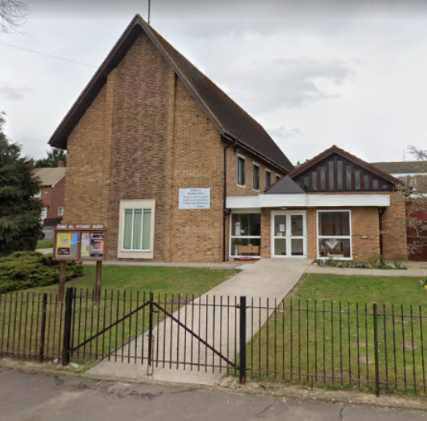
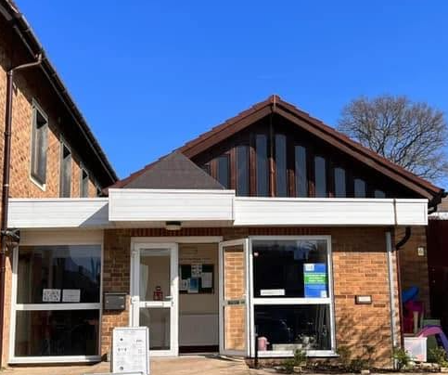 | 

Proposal For

GRANGE HILL METHODIST CHURCH

By
FENSTER GLAZING & LOCKS LTD.

Prepared For

CHIGWELL GROUP

Thank you for choosing Fenster Glazing to support you on this project.
Client: Chigwell Group
FAO: Luke Baker
Project Reference: Grange Hill Methodist Church Ext
Site Address: Burrow Rd, Chigwell, IG7 4HQ
Date: 29/07/2026

Executive Summary
Fenster Glazing are pleased to submit our proposal for the Windows and Doors package at Grange Hill Methodist Church, Burrow Road, Chigwell, Essex, IG7 4HQ. The works form part of the proposed new single-storey entrance building / church extension, with the tender register identifying the project as EST 122 Grange Hill Methodist Church Ext.
The project includes a new entrance extension to the front of the church, with a pitched roof following the existing roof line and a glazed frontage to the new entrance building. The structural design notes that the glazed front entrance is to be designed by a specialist, with a horizontal restraint beam provided to allow the glazing specialist to restrain their frame laterally.
Our proposal includes the manufacture, supply and installation of aluminium windows, external aluminium doors and glazed entrance screen elements to the south and west elevations only, where quoted. The drawings note that windows and doors to the south and west elevations are to be white aluminium framed, with no new windows to the east elevation.
The window package is based on Sheerline Prestige aluminium casement windows in Hipca White, with concealed drainage, cills and solar control double glazed units where quoted. The door and screen package is based on SMA Smart Wall Pocket aluminium anti-fingertrap doors, including single doors and door screen elements with fixed fields, finished white, with laminated / toughened solar control glazing and panic hardware where quoted. Internal bifold doors have not been allowed, as the supplier confirmed these were not included.
For a full breakdown of costs please refer to our relevant pricing document.
DESCRIPTION & CLARIFICATIONS | PRODUCTS
- Supply and install aluminium windows, external doors and glazed entrance screen elements to the south and west elevations only at Grange Hill Methodist Church.  - Cost is subject to final design approval, site survey and confirmation of structural openings.  - Installation is included within our costs.  - External mastic is charged as an optional extra.  - Fenster’s tender is based upon the tender drawings, structural information, document register, supplier quotations and supplier clarification provided. Our scope is limited to the manufacture, supply and installation of aluminium windows, external aluminium doors and glazed entrance screen elements where quoted only. Internal bifold doors, internal screens, structural steelwork, restraint beam design, foundations, brickwork, roofing, M&E works, access control, door sensors, making good, decoration and principal design responsibilities are excluded unless specifically agreed. | Aluminium  Sheerline Aluminium windows  SMA Smart Wall Pocket aluminium anti-fingertrap doors  Glazing Specification  Windows: 6mm toughened / 6mm toughened Solar glazing  Doors / screens: 8.8mm laminated / 6mm toughened Solar glazing
SUBTOTAL: | £39,006.77 + VAT

NCLUSIONS | EXCLUSIONS
General Arrangement and Sectional Drawings – Initial and revised drawings, as well as built drawings included within cost  Risk Assessments and Method Statements – Issued 2 weeks prior to commencement on site, for approval  Site Survey – Only conducted once the structural openings are fully formed. Any revisits may be subject to a fee  Installation – Installation is included within our costs as per final agreed programme. Any delay outside of Fenster’s control may incur additional costs  Project & Contracts Management – A dedicated project manager and separate contracts manager will be assigned to the project until practical completion  Quality Assurance – Full sign-off documentation and final snagging will be provided  Phased Delivery & Material Handling – Any site limitations to be highlighted  Site Supervision – CSCS/SMSTS Qualified Site Supervisor to be in full-time attendance  Working Hours – Based on normal working hours of Monday – Friday 07:30 - 16:30, excluding bank holidays, unless otherwise agreed. Any Out-of-Hours works to be pre-agreed  O&M Manual – To be issued following receipt of final payment  Samples – Samples can be provided upon request, but are not always available for certain products | Site Welfare – Welfare facilities, power, water, lighting  Access/Lifting Equipment – Scaffold, MEWPS, Towers, Forklift etc.  Site Storage – Materials will be delivered to site  Fire Stopping – To be done by others, if required  Waste Removal – Generally excluded unless agreed otherwise  Internal Finishing – Primarily excluded unless agreed otherwise  Final Clean on handover – Final clean and removal of protection tape to be completed by client  Testing – On or off site testing  Structural Alterations – To be completed by Main Contractor  Design Responsibility – Design calculations, structural calculations and engineer approvals unless specifically included within our scope  Traffic Management – Road closures, street licenses, parking suspensions  Additional Limitations – Dimensions provided by others are assumed to be accurate. Any additional costs arising from incorrect dimensions shall be treated as a variation and charged accordingly

Project Approach

- Technical Review & Survey

Following appointment, Fenster Glazing will review all project documentation and undertake a detailed site survey to verify dimensions, interfaces and installation requirements. Any discrepancies or technical queries identified will be raised and resolved prior to manufacture.
- Procurement & Manufacture

Materials will be procured through our established supply chain following survey completion and approval of all relevant information. Fabrication drawings will be produced where required to support manufacture and installation activities.
- Project Management

A dedicated Project Manager and Installation Manager will be assigned to oversee the works from award through to completion. Pre-start meetings, regular progress updates and proactive communication ensure effective coordination throughout the project.
- Installation

Installation works will be undertaken by experienced glazing operatives in accordance with project-specific RAMS, agreed site phasing and Principal Contractor requirements. Particular consideration is given to working within occupied buildings and live environments where disruption must be minimised.
- Quality Assurance & Handover

Quality inspections are undertaken throughout survey, manufacture and installation activities in accordance with our QA procedures. Upon completion, internal snagging inspections will be carried out prior to handover, with all relevant warranties, O&M information and project documentation provided as part of the close-out process.

Previous Projects
Further Completed Projects can be found on our website: fensterglazing.com/commercial
HEADROW COURT - LEEDS | 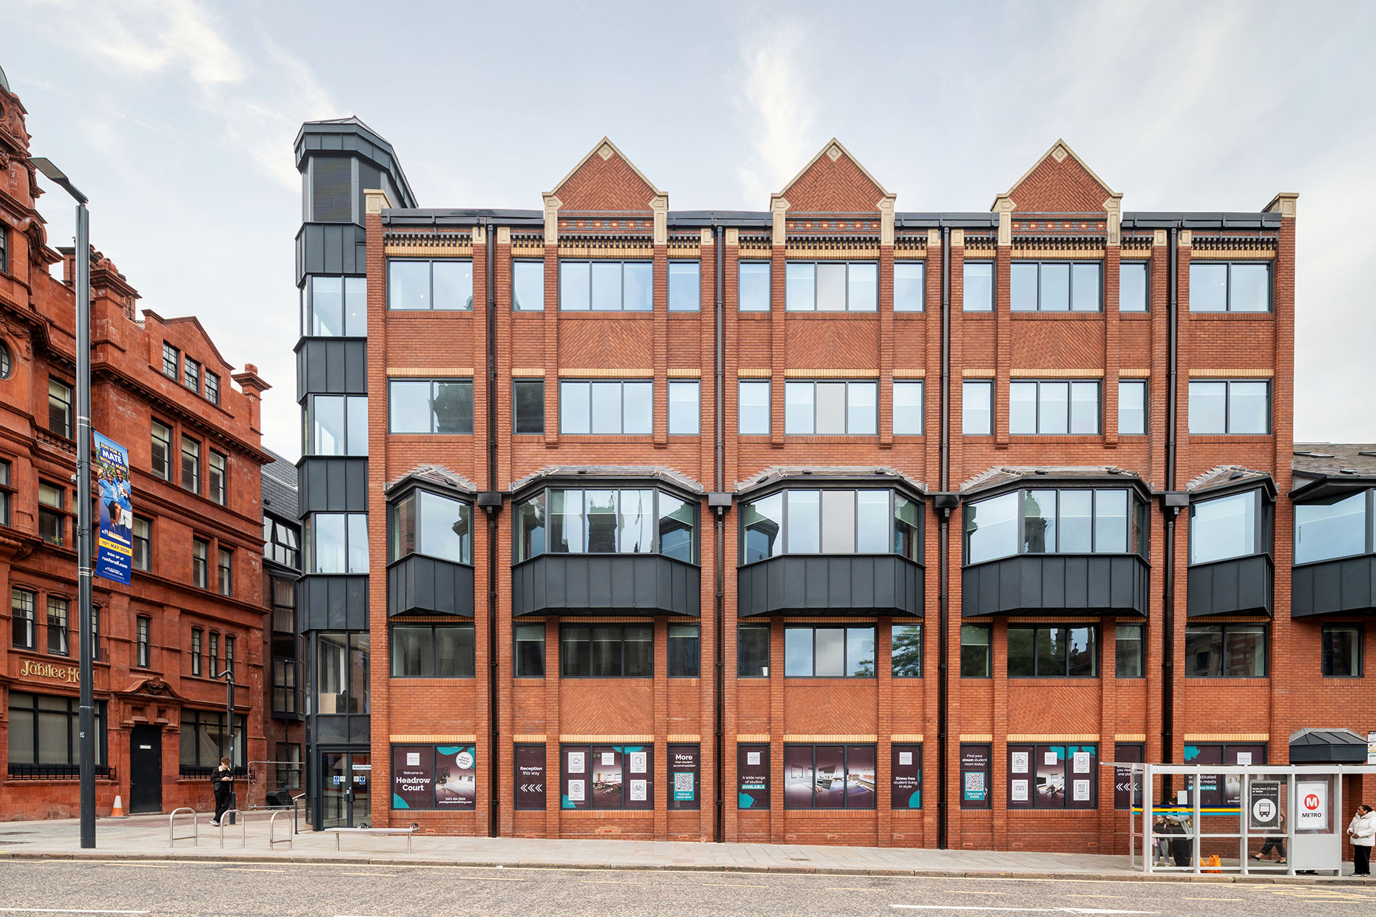
Scope: Replacement Aluminium windows, doors and curtain wall
Value: £630,000

Key Project Features: Occupied city-centre location requiring phased installation and careful logistics management
BLETCHLEY RAIL DEPOT – MILTON KEYNES | 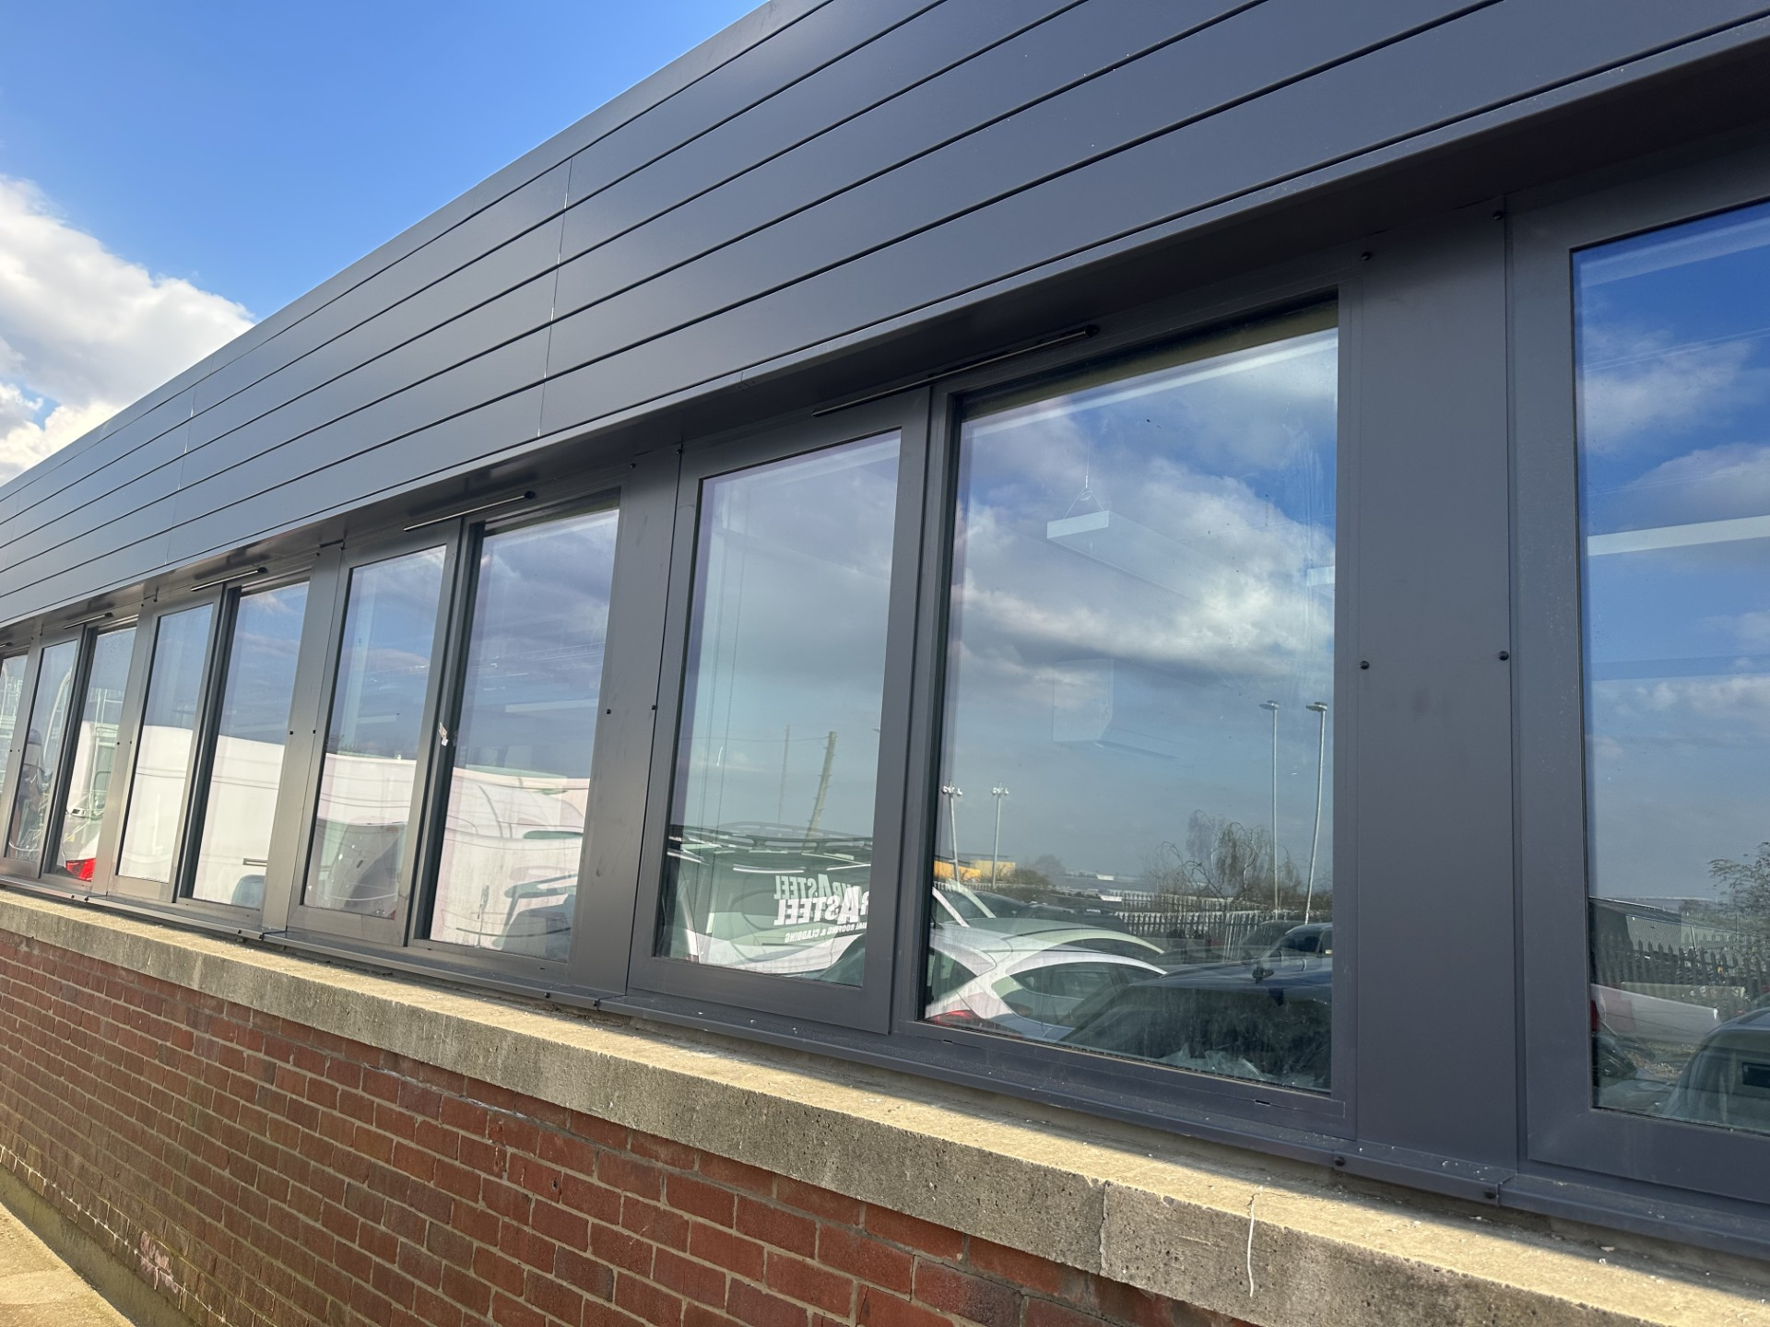
Scope: Replacement Aluminium windows, doors and curtain wall
Value: £190,000

Key Project Features: Works undertaken within a live operational environment with restricted access requirements
DWP – TOTTENHAM | 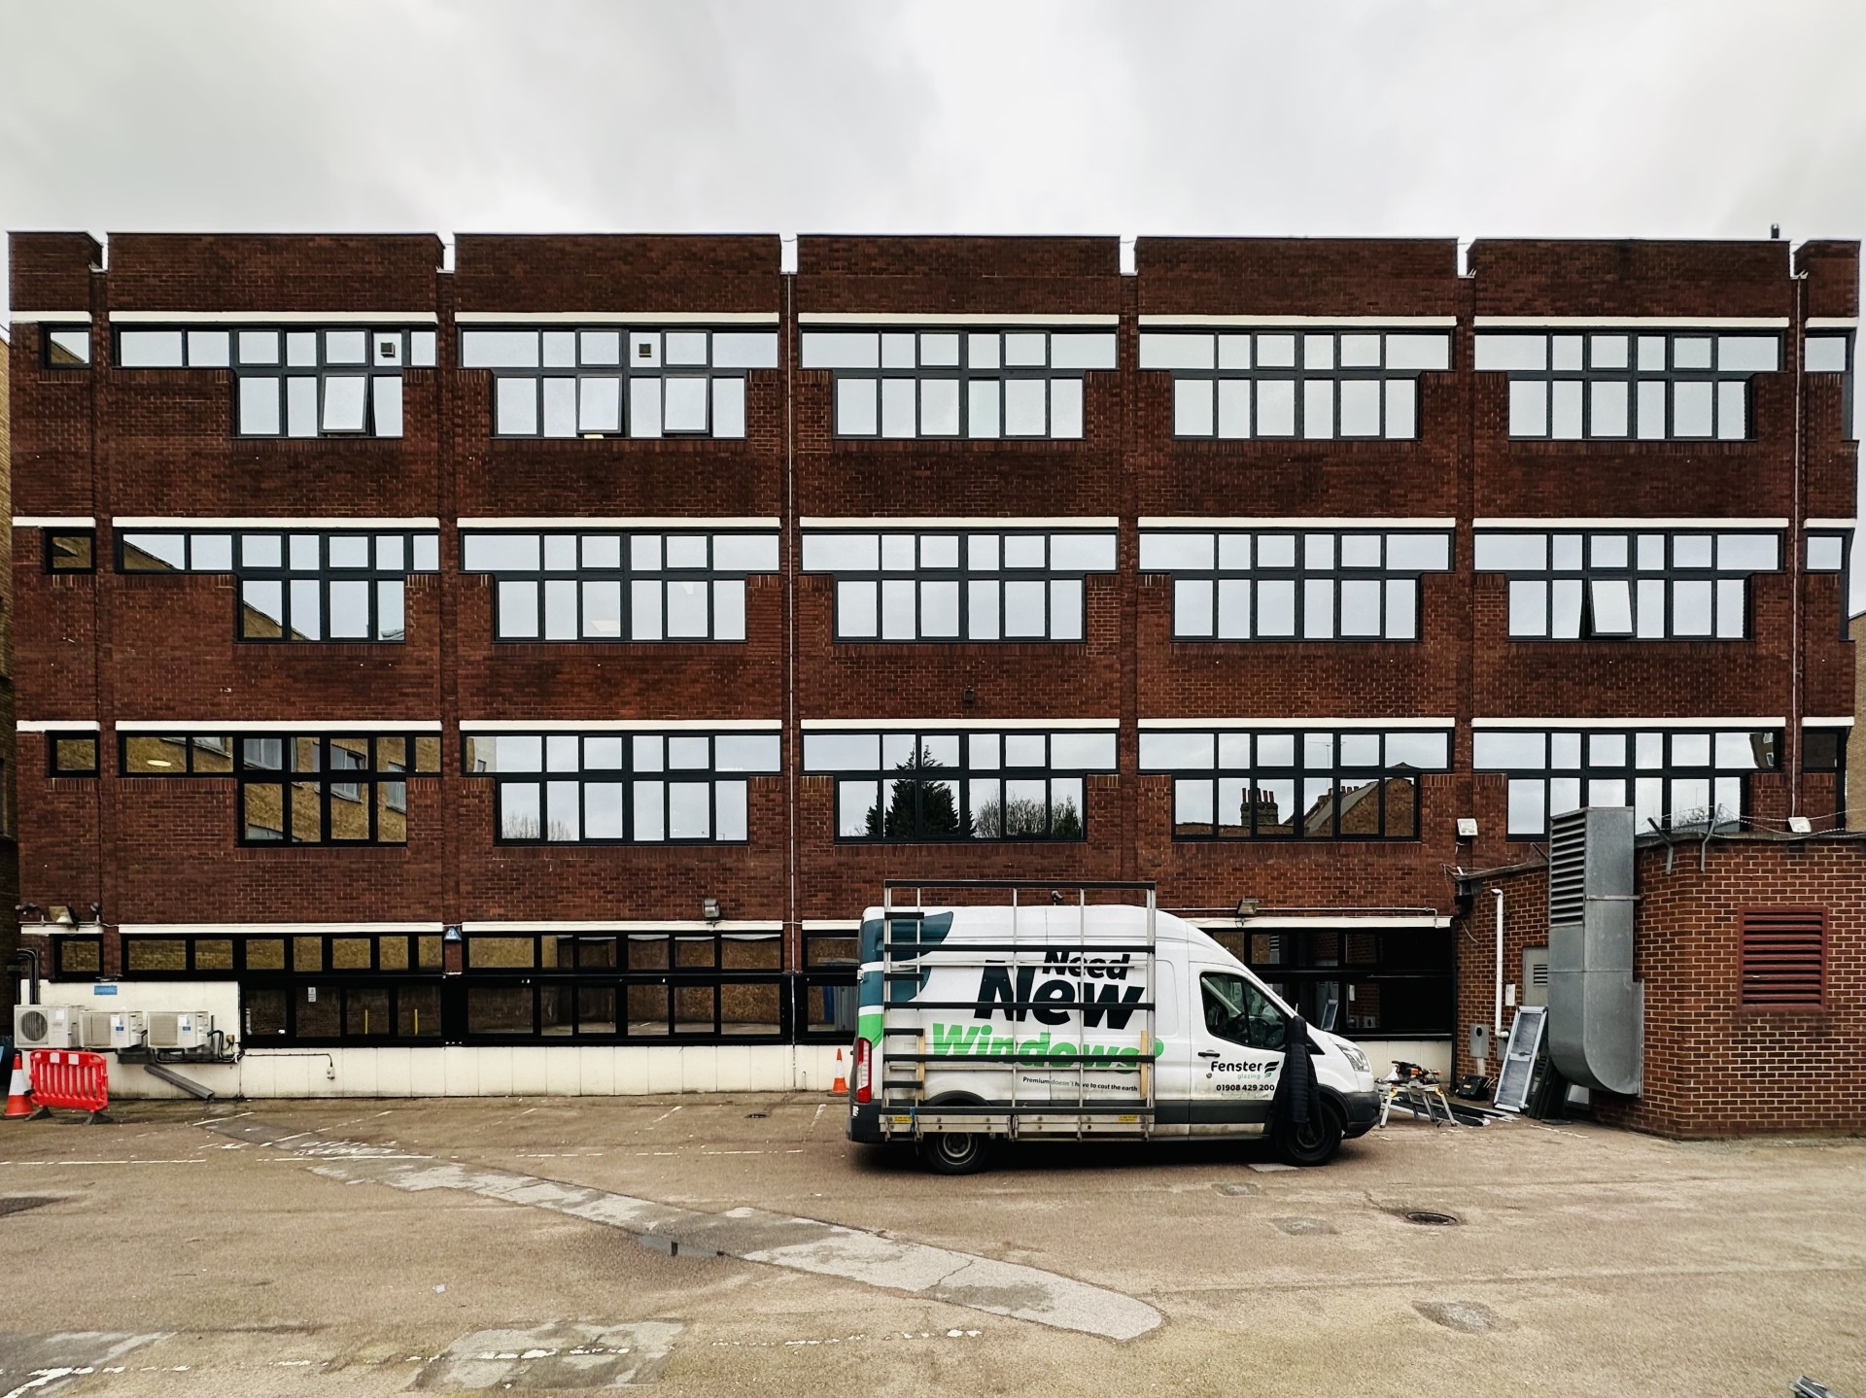
Scope: Replacement Aluminium windows, automated doors, glazed canopies and curtain wall
Value: £585,000

Key Project Features: Phased installation programme undertaken while maintaining building operation

Project Delivery Team

Adam Butcher  Commercial Director  adam@fensterglazing.com  01908 429200 (option 2) | Steven Freezer  Technical Advisor  steven@fensterglazing.com  01908 429200 (option 2)
Paul Taylor  Project Manager  paul@fensterglazing.com  01908 429200 (option 2) | Gintare Vanagaite  Estimator  estimating@fensterglazing.com  07946 080965
David Foord  Site Manager  david@fensterglazing.com  01908 429200 (option 2) | 

TERMS AND CONDITIONS
- Consumer Notice
Where the client is acting as a consumer, nothing in these Terms and Conditions shall affect the client’s statutory rights under the Consumer Rights Act 2015 or related consumer protection legislation.
- Quotation Validity
All quotations provided by Fenster Glazing & Locks Ltd are valid for 30 days from the date of issue, unless agreed otherwise. All quotations are subject to final site survey and measurement verification.
- Deposit and Payment Terms
Fenster Glazing & Locks Ltd requires receipt of a Purchase Order or a deposit of 50% of the total quotation value prior to commencement of works, in order to secure scheduling and procurement of materials. The remaining 50% balance is due upon completion of installation and client sign-off.
- Late Payment
All invoices are payable in accordance with the terms above. Any sums not paid within 30 calendar days of the invoice date will be considered overdue and will attract interest at the statutory rate of 4% per annum above the Bank of England base rate, applicable at the time.
- Guarantee and Warranty
Fenster Glazing & Locks Ltd provides a 10-year warranty covering all glass and frame products supplied and installed by the company. This warranty covers defects in materials (as supplied) and workmanship (installation). Furthermore, this warranty is subject to the terms and conditions of any applicable manufacturer warranties. It does not cover damage resulting from misuse, accidental or intentional damage, vandalism, inadequate or incorrect maintenance, or external factors, including severe weather conditions.
- Order Confirmation & Site Survey
Upon receipt of a valid Purchase Order, the quotation shall be converted into an order confirmation. A site survey shall then be undertaken to verify final measurements and site conditions. Where required, the order confirmation shall be updated and reissued to reflect verified measurements or agreed amendments.
A sign-off sheet will be issued for client approval prior to manufacture or procurement of materials. Any changes to specifications, measurements, or costs identified as a result of the site survey or client-requested amendments shall be confirmed in writing and agreed prior to proceeding.
- Manufacture, Delivery, and Installation
Manufacture and procurement of materials shall commence only following receipt of the signed sign-off sheet. Once manufacture has commenced, changes or cancellations may not be possible and, where accommodated, may be subject to additional costs and revised lead times.
Upon completion of manufacture, goods shall be delivered either to Fenster Glazing & Locks Ltd’s warehouse or directly to site, as agreed. Installation shall be carried out by Fenster Glazing & Locks Ltd in accordance with the agreed order confirmation and programme.
Installation dates are indicative and subject to site readiness, access, and the client fulfilling its obligations.
- Supplier Delays and Liability
Fenster Glazing & Locks Ltd shall not be liable for delays, additional costs, losses, or consequential damages arising from delays, defects, or errors caused by third-party suppliers or manufacturers.
Fenster Glazing & Locks Ltd will use reasonable endeavours to mitigate the impact of such delays and shall keep the client informed of any material changes to programme or availability. Where reasonably possible, alternative solutions may be proposed for the client’s consideration.
- Site Access and Conditions
The client shall be responsible for ensuring that safe, clear, and uninterrupted access to the installation site is available during agreed working hours and that site conditions are suitable for the works to proceed.
Fenster Glazing & Locks Ltd reserves the right to suspend works where suitable access or site conditions are not provided. Any additional costs incurred as a result of restricted access, inadequate site conditions, or delays beyond Fenster Glazing & Locks Ltd’s control may be charged to the client.
- Health and Safety
Fenster Glazing & Locks Ltd shall carry out all works in accordance with applicable UK health and safety legislation. The client shall be responsible for ensuring that the site and working environment comply with all relevant health and safety requirements, including the Construction (Design and Management) Regulations 2015.
Fenster Glazing & Locks Ltd reserves the right to suspend works without penalty where site conditions are deemed unsafe or non-compliant with applicable health and safety requirements.
- Cancellation and Postponement
Should the client cancel or postpone the contract following procurement of materials or commencement of works, Fenster Glazing & Locks Ltd reserves the right to retain the deposit and recover any additional costs incurred up to the date of cancellation or postponement.
All goods supplied by Fenster Glazing & Locks Ltd are bespoke or made to order, and retention of the deposit reflects costs incurred in procurement, manufacture, and administration.
- Force Majeure
Fenster Glazing & Locks Ltd shall not be liable for any failure or delay in the performance of its obligations under this agreement where such failure or delay arises from events or circumstances beyond its reasonable control, including but not limited to natural disasters, extreme weather conditions, industrial action, government restrictions, pandemics, or significant supply chain disruption.
- Limitation of Liability
To the extent permitted by law, Fenster Glazing & Locks Ltd’s total liability arising out of or in connection with the contract shall be limited to the total contract value. Fenster Glazing & Locks Ltd shall not be liable for any indirect or consequential loss, loss of profit, or loss of business.
Nothing in these Terms and Conditions shall limit or exclude liability for death or personal injury caused by negligence, fraud, or any matter which cannot lawfully be excluded.
- Retention of Title
All materials supplied by Fenster Glazing & Locks Ltd shall remain the property of Fenster Glazing & Locks Ltd until payment has been received in full.
- Intellectual Property
All design work, drawings, plans, and bespoke glazing system solutions provided by Fenster Glazing & Locks Ltd shall remain the intellectual property of Fenster Glazing & Locks Ltd unless otherwise agreed in writing.
The client shall not reproduce or permit use of such materials by third parties without prior written consent.
- Design Responsibility
Fenster Glazing & Locks Ltd is not responsible for overall design intent, architectural suitability, or regulatory strategy and relies on information, drawings, and specifications provided by the client or their professional team. Responsibility is limited to measurement verification, supply, and installation of the agreed glazing systems.
- Dispute Resolution
Fenster Glazing & Locks Ltd aims to resolve any disputes amicably and professionally. Where a dispute cannot be resolved through informal discussion, the parties shall first seek to resolve the matter through mediation by an independent mediator agreed between them, prior to commencing any legal proceedings.
Nothing in this clause shall prevent either party from seeking urgent injunctive or interim relief.
- Governing Law and Jurisdiction
These Terms and Conditions shall be governed by and construed in accordance with the laws of England and Wales. The parties agree to submit to the exclusive jurisdiction of the courts of England and Wales in relation to any dispute arising out of or in connection with these Terms and Conditions.
- Acceptance
By engaging Fenster Glazing & Locks Ltd for the supply of goods and provision of installation services, the client confirms acceptance of these Standard Terms and Conditions, unless otherwise expressly agreed in writing.
- Amendments to Terms and Conditions
Fenster Glazing & Locks Ltd reserves the right to amend these Terms and Conditions from time to time. Where any material amendments are made, clients will be notified in writing.
Any amendments shall apply to future contracts only and shall not affect existing agreements unless agreed in writing.

